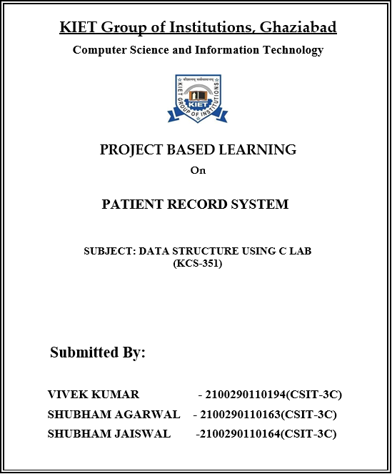

**ACKNOWLEDGEMENT**

## I’ve got this golden opportunity to express my kind gratitude and sincere thanks to my subject faculty **“Mr. VINAY KUMAR”**, Computer Science and Information Technology Department, **KIET GROUP OF INSTITUTIONS** for their kind support and necessary counselling in the preparation of this project report. I’m also indebted to each and every person responsible for the making up of this project directly or indirectly.

I must also acknowledge or deep debt of gratitude each one of my colleague who led this project come out in the way it is. It’s my hard work and untiring sincere efforts and mutual cooperation to bring out the project work. Last but not the least, I would like to thank my parents for their sound counselling and cheerful support. They have always inspired us and kept our spirit up.

**Aim:** To make an patient record system and store data of the patient.

**Objective:** Records Serve to document the history of the client.

**Abstract:** Recent research states that using new and emerging technologies in the areas of telecommunications are widely used in healthcare sector. The system Electornic Patient Record Management System (EPRMS) is a centralized database contains the in-patient record. It was implemented using PHP & MYSQL combination. The database record contains the patient personal info, department lies-in, physician, tours, ,treatment and lab results. Since the patient enters the hospital the workflow starts as the reception user creates new record by entering the personal info and sends the record to assigned department; at this stage the nurse starts update the record by entering the physician comments, required treatment, and sends lab test when it is required. The procedure continues as long as the patient still in the hospital. At last when the patient recovered or died the International Classsification of Diseases(ICD) inserted to the record and out or died date. In addition there are many supported tables that can be updated manually through independent pages by IT administrator. These tables like Physician names, medicines, lab tests, users and ICDs. As the system consists of different users and different user permissions. Also there are advance search that can help to make statistical reports and researches for the physicians. The system is considered time and cost effective to healthcare.

**Basic principle:** Records serve to recognize the health needs and can be used as a research and teaching tool.

**Methodology:** To arrange the data in structures.

# Architecture:

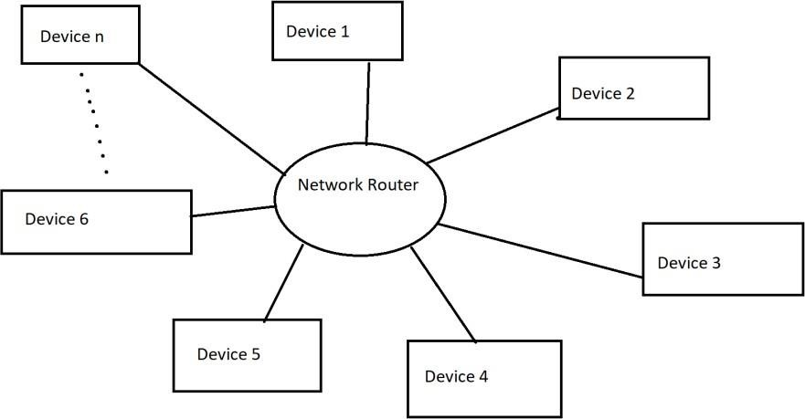

# CODING IMPLEMENTATION

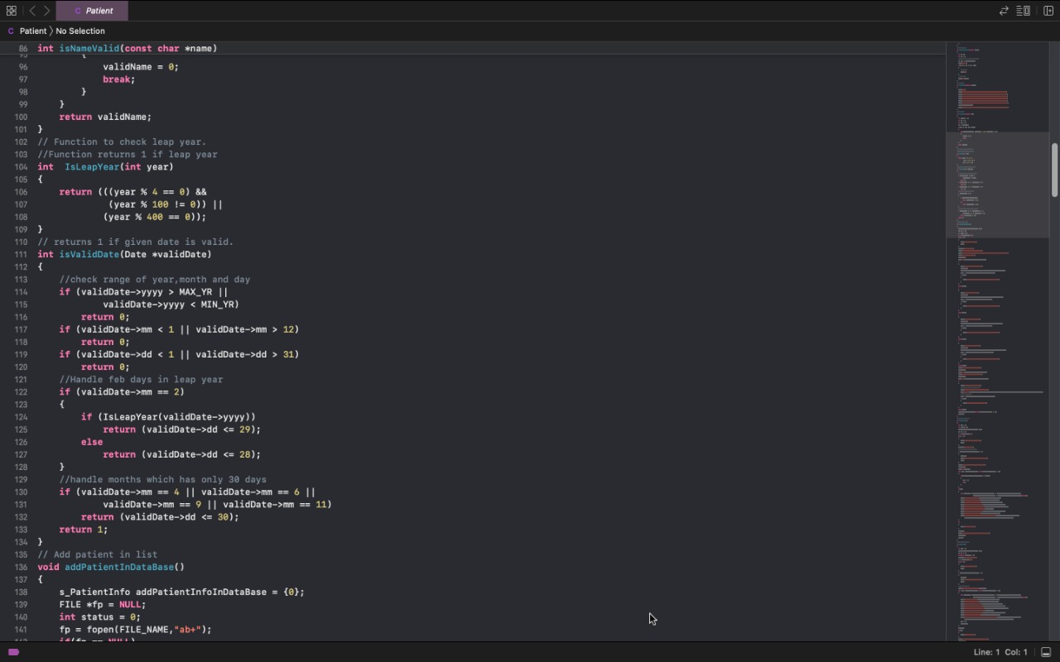

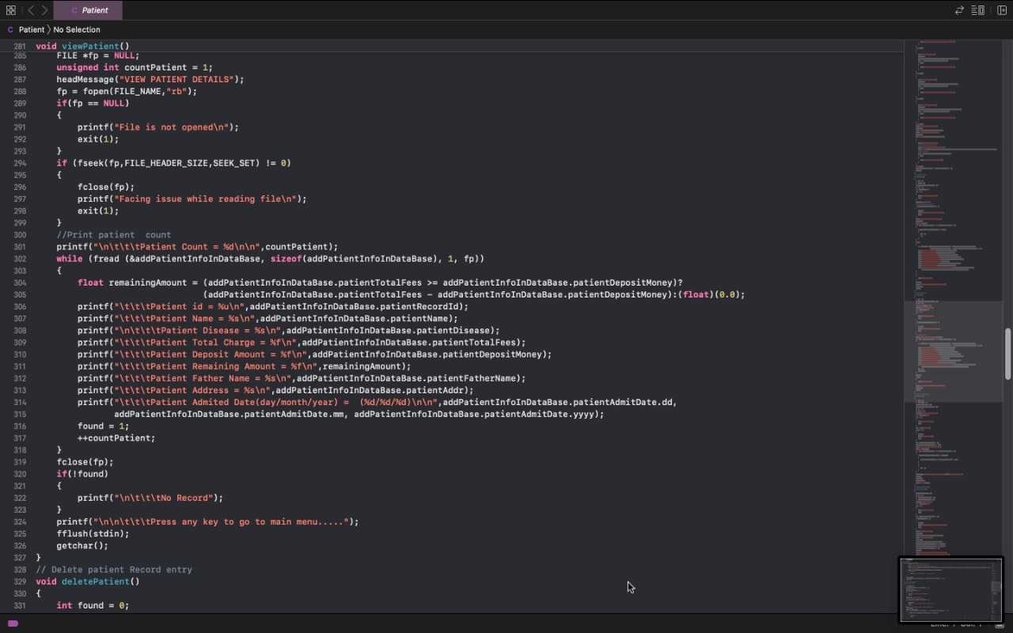

**OUTPUT**

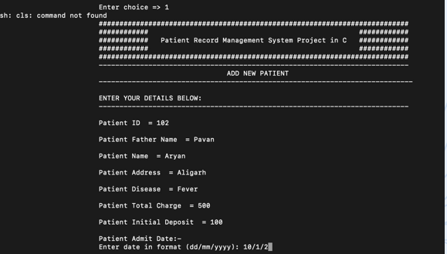

**REFRENCE:**

1. https://www.youtube.com/watch?v=udA9p-WFE1k